Software Requirements Specification

for



**Version 2.0**

**Prepared by**

**Team Phoenix**

|  |  |  |
| --- | --- | --- |
|  |  |  |

**Revisions**

|  |  |  |  |
| --- | --- | --- | --- |
| **Version** | **Primary Author(s)** | **Description of Version** | **Date Completed** |
| 2.0 | Team Phoenix | The final version of the SRS document has been drafted with all the requirements being incorporated into the document. | 12/02/13 |

Table:1

# 

# 

# *.*

# 

# 

# Introduction

## 1.1 Document Purpose

The main purpose that banks have been serving since their inception is keeping our money safe for us. While keeping our money safe, they also let us earn a certain amount of interest on the money deposited with them. Traditional banks have been doing this, and internet banks continue the same function. The only difference is in the way the transactions are made.

The aim of this project is to develop a secured online banking system with the following objectives:

 Create a banking system that is easily accessible by customers from the comfort of their homes, offices etc.

 Reduce the flow of human traffic and long queues at banks.

 Promote efficient and effective banking for the banks by focusing on those services that still require physical

presence at the banking hall.

## 1.2 Product Scope

The Scope of this project is limited to the activities of the operation units of the banking system which include opening of account, credit and debit amount, balance enquiry and view transaction logs.

## 1.3 Intended Audience and Document Overview

**1.3.1** **Intended Audience:**

(a). Customers.

->Project Scope.

->Security Available.

(b). Employers.

(c). Developers.

->Project Scope.

-> Use Case Module.

(d). Project Manager.

->System Features.

-> Hardware Requirement.

->Software Requirement.

->Interface Requirement.

**1.3.2** **Document Overview:**

## 

## 1.4 Definitions, Acronyms and Abbreviations

1. ->Account Details.
2. ->ATM Request Form.
3. ->New Account Opening Form
4. Abbreviation Used:-
5. PAN – Permanent Account Number.
6. DD - Demand Draft
7. SB - Saving Bank
8. CA - Current Account.
9. ATM – Automatic Teller Machine.

## 1.5 User Documentation

1. A registered user can have following facilities:
2. -> Accounts and accounts status.
3. -> The balance enquiry.
4. -> The transaction logs.

## 1.6 References and Acknowledgments

**1.6.1 References:**

**1.6.2 Acknowledgments:**

***2.* Overall Description**

11

## 2.1 Product Perspective

1. The client will have client interface in which he can interact with the
2. banking system. It is a web based interface which will be the web
3. page of the banking application. Starting a page is displayed
4. asking the type of customer he is whether ordinary or
5. a corporate customer. Then the page is redirected to login page
6. where the user can enter the login details. If the login particulars are valid then the user is taken to a home page where he has the
7. entire transaction list that he can perform with the bank. All the above activities come under the client interface. The administrator
8. will have an administrative interface which is a GUI sothat he can view the entire system. He will also have a login page where

he can enter the login particulars so that he can perform all his actions. This

administrative interface provides different environment such that he can maintain database & provide backups for the information in the database. He can register the users by providing them with username, password & by creating account in the database. He can view the cheque book request & perform action to issue the cheque books to

the clients.

## 

## 2.2 Product Functionality

1. The Internet banking system consists of following modules :
2. ->Login/Create a bank account
3. ->Credit and debit amount
4. ->Balance inquiry
5. ->View transaction logs

## 2.3 Users and Characteristics

## 2.4 Operating Environment

## 2.5 Design and Implementation Constraints

## 2.6 User Documentation

## 2.7 Assumptions and Dependencies

***3.* Specific Requirements**

## 

**3.1.** **External Interface Requirements**

### 3.1.1. User Interfaces

### 3.1.2. Hardware Interfaces

Not applicable.

### 3.1.3. Software Interfaces

### 3.1.4. Communications Interfaces

## 

## 

## 

## 3.2. Functional Requirements

## 3.3. Behavior Requirements

### 3.3.1 Use Case View

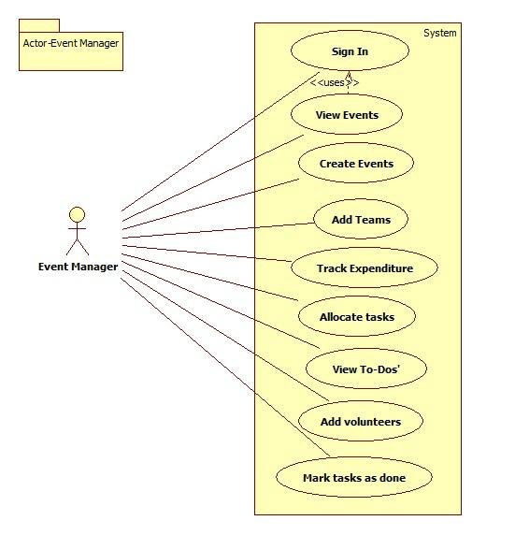

Fig 3.3.1 (a)

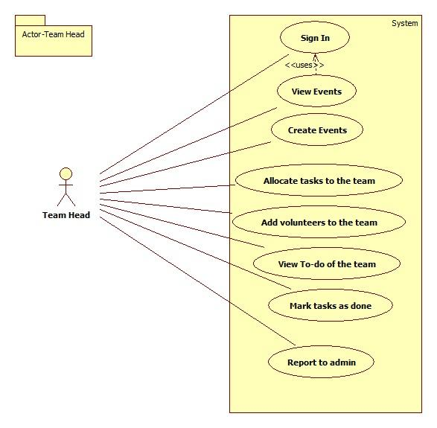

Fig 3.3.1 (b)

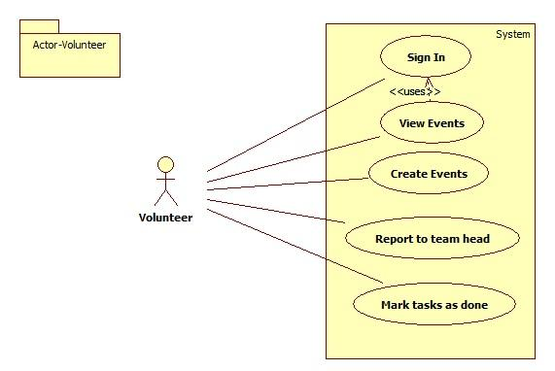

Fig 3.3.1(c)

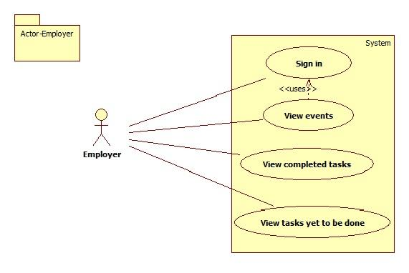

Fig 3.3.1 (d)

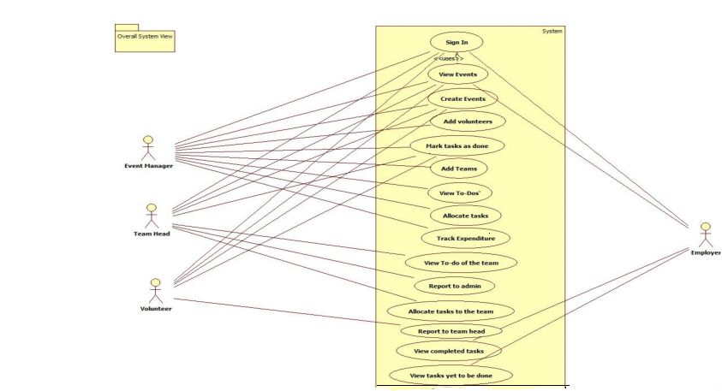

Fig 3.3.1(e)

# *4.* Other Non-functional Requirements

## 4.1. Performance Requirements

* Any transaction will not take more than 10 seconds.
* Multiple users are supported.

## 4.2. Safety and Security Requirements

* The user has to login using the secure OpenID.
* Expenditure details are viewable only to the Event Manager.
* A log file about server activity must be maintained for better crash recovery and security.

## 4.3. Software Quality Attributes

The software will be built on a popular python based framework called Django, which follows Model Template View principle. Since the business logic, presentation layer and database layer are 3 independent entities bound by together by application logic it is easy to add more features in the future.

Due to the MTV structure of the framework, Django, the product is easily maintainable.

That is, one can avoid ripple changes throughout the entire code thus making the task of maintenance more effective and easy. The unit testing modules in python makes the task of testing better.

# 

# 

# 

# 

# *5.* Other Requirements

**5.1 Requirements Elicitation:**

Interviews were conducted to get a better picture of the requirements of the user:

1) Abhishek ,Secretary of “Saahaayyam dridha” was interviewed by Anil kumar V.

Saahaayyam dridha is a public charitable trust in Raichur. This trust has in the past organised a full day cultural event for children. The details of the management of the event(by dividing the manpower) are as follows:

1) Core team.

2) Event coordinator.

3) Logistics.

4) Finance and fund raising.

5) Communication team.

6) Program coordinator.

7) workload coordinators.

8) Others.

**Roles of the volunteering teams**

1) Core team

a) Group of experienced people.

b) Reviewing the volunteering teams.

c) Suggestions to make the event successful.

2) Event coordinator

a) Conduction of competitions on the day of event.

b) Handing over the materials to the judges.

3) Logistics

a) Food management.

b) Transport.

4) Finance and Fund raising

a) Get the sponsors.

b) Raise funds required for the event.

c) Take care of financial accounts.

5) Communication

a) Media.

b) Marketing.

c) Documentation.

6) Program coordinator

a) Program schedule management on the day of the event.

7) Workload coordinators

a) Getting the materials required for the event(things used for cooking).

b) Stage management.

8) Others

a) Help desk on the day of event.

b) Emergency conditions.

2) With respect to this project, we, Megha.L.S and Prashant Kumar, interviewed Mr. Harsh Golyan who has worked in three different Event Management Companies. He enlightened us with the teams that volunteers are divided into while organising different types of events. He also helped us get a clearer picture about the way an event is organised. Few of the teams he mentioned are as follows:-

* Catering
* Stage and Infrastructure
* Hospitality
* Public Relations
* Transportation
* Security
* Finance
* Logistics

This interview has given us an idea on the type of templates to provide to an event manager for particular types of events.We thank Mr.Golyan for taking some time out to share his valuable input with us.

3) **Event**: Concert.

**Interviewed**: Prathik.

Organized a concert.

· Things to be done first,

* + Permission from government authorities.
  + Distribution of tasks.

Stage design.

Technicians.

Food and beverages.

Security.

Publicity.

Finance.

Hospitality.

Cleaners.

· Things to take care for a performer,

Travel expenses.

Stay.

Food and beverages.

Security.

Equipments.

Crackers(optional).

· Things to take care for public,

Security.

Food and beverages(optional).

Parking facility.

**4) Technical event**

Mr. Rakesh Kumar who had been a part of technical event organizing team for hackathons like Ayana and hashcode was interviewed regarding the actors and teams that are involved in the process of organizing such an event.

Apart from the above mentioned teams there is a need of strong tech team expertised in various technologies involved in the event. A network team also is a must. He also stated that developing such a software can be extremely helpful for novice event managers.

**5.2 Technical Feasibility:**

A series of interviews with event managers were held to gather their requirements and to gauge if the software, Event4u is feasible to implement.

Technical feasibility:

For the implementation of the software, Event4u, the technical resources needed were estimated.

The current solution to the software was decided based on

* The complexity of the technical resources needed.
* The manpower needed to implement the project.
* Team member's prior experience with the technology.
* Ease of learning the implementation tool that is django.
* The limited time constraint empowered by django which is specialised for

agile development.

**Appendix A – Data Dictionary**

|  |  |  |
| --- | --- | --- |
| 1 | Employer | Employer is an individual who has contacted the event organiser. |
| 2 | Event Manager | Event Manager is an individual who is responsible for the whole event and can view the entirety of the event being planned on the software.He/She is usually the lead event organiser. |
| 3 | HTTPS | HTTPS stands for Hypertext Transfer Protocol Secure.This protocol is a widely used communications protocol for secure communication over a computer network, with especially wide deployment on the Internet. |
| 4 | OpenID | OpenID is a decentralized single sign-on authentication system for the Internet. The goal of the OpenID initiative is to allow users to log in at websites around the Internet with one ID, instead of having to create multiple unique accounts. |
| 5 | SRS | SRS stands for Software Requirement Specification. It is his used to refer to a document that completely describes all of the functions of a proposed system and the constraints under which it must operate. |
| 6 | Team Head | Team head is an individual who is responsible for all the actions undergoing under his/her team. |
| 7 | UI | UI stands for User Interface. It is defined as the space where interaction between humans and machines occurs. |
| 8 | View | View means to display and look at data on screen. |
| 9 | Volunteer | Volunteer is a person who offers to take part and help in organizing the event. |

**Appendix B - Group Log**

**Date :23/1/2013 (2.30 p.m)**

**Duration: 1 hour**

**Co-ordinator: Navaneeth Y.V**

**All members present**

The first team meeting took place on this day. After a friendly chat ,it was decided that we would observe and find out any sort of a problem and would decide on its feasibility as an application software.

**Date :24/1/2013 (3.30 pm)**

**Duration:30 minutes**

**Co-ordinator:Navaneeth Y.V**

**All members present**

Interesting ideas were put across and we made a brief discussion on which among them would be feasible to implement in the given time period. Since all the ideas were equally good we did not come into a mutual accord.Some of the ideas put across were :

1.To have a software for better schemes for toll booths.

2.A software that tracks corruption and gives information to common man.

3.To develop a software for knowledge of exact rates of trasportation.

4.A portal that will help student to prepare for interviews and aptitude during placements.

5. Software to implement Intelligent traffic signals.

6.Improve and develop another version of Gems.

We decided to take a day off to come up with more feasible ideas.

**Date:26/1/2013 (8:30 P.M)**

**Duration:2 hours**

**Co-ordinator: Megha L.S**

**All members present**

The approach with which the scope had to be presented was discussed and we decided to go with the observation->problem->Solution model.After a final group chat on saturday we finalised the Event Management Centre(Name yet to be finalised).The temporary name was given by Navaneeth and Prashant as **Event4u.**

**Date :29/1/2013(1.30 pm)**

**Duration: 45 mins**

**Co-ordinator: Ankita Singh**

**All members present**

The project Scope was given an approval. We decided to work towards the requirements of our project which has been asked to be submitted by 5th February . As the first step is to inquire and get more knowledge about the particular field we are making the software for,we all decided to take interviews from people involved in organising events and members of different companies involved in the event management field.

Our team decided and agreed upon the fact that we’ll have an online meet at 9 P.M every day for better coordination and interaction.

**End-Result:** Each member of the group was assigned a particular type of event by the group leader.Each group member took upon the responsibility of researching more about that specific event and getting the requirements by interviewing the necessary people.

**Task assignment :**

Navaneeth - technical events

Ankita Singh and Juhi Khandelwal- fashion shows

Anil and Nirosha - Formal Cultural events

Karun Karthik - Concerts

Chetan - Inaugural ceremony

Megha and Prashant - College Cultural events

**Date :30/1/2013(3.30 pm)**

**Duration: 30 mins**

**Co-ordinator: Anil Reddy**

**All members present**

Every person of the group were told to brief about the information they gathered regarding the events that was assigned to them. Since it was not very much refined it was decided that we would continue with the same set of people to refine their idea.

**Date :31/1/2013(3.30 pm)**

**Duration: 30 mins**

**Co-ordinator: Prashant kumar**

**All members present**

The requirements for all the events were brief, but comprehensive this time. Queries regarding the decided events were answered by the team member in charge of the task of knowing the event , thus tying up the loose ends. Now the team has a clear idea of what is to be dealt with. Team members were given time to review the SRS template and to think of the details that can be put since they have a better idea of the events to be handled by the proposed software.

**Date :1/2/2013(3.30 pm)**

**Duration: 30 mins**

**Co-ordinator: Nirosha**

**All members present**

An assignment regarding cleanroom SE was to be submitted before saturday. The team members, well advised before via e-mail, came with their thoughts regarding cleanroom SE. Every one were asked to write their thoughts on cleanroom SE , which was to be collaborated by Friday. Each one also explained their progress with the SRS template. Each team member talked about their interests regarding coding , designing, their experiences in various programming languages. A brief discussion regarding how the application should run as a web service also took place.

**Date :2/2/2013(4.00 pm)**

**Duration: 30 mins**

**Co-ordinator: Juhi Khandelwal**

**All members present**

Assignment regarding Cleanroom SE was successfully completed and was submitted. Project manager decided to build a SWAT (Skilled Worker with Advance Tools) team for the project development because of the deadline criteria.

The team was divided into 3 equally important parts for the earlier stage of product development.

**Designers**

Nirosha

Karun Karthik

**Implementors**

Front end

Anil Kumar V

Prashant Kumar

Back end

Navaneeth Y.V

Megha L.S

**Testers**

Chetan K.S

Juhi Khandelwal

**Documentation head**

Ankita Singh

The designers were asked to come up with designs for the web pages involved in the software which is shown in SRS v1.0. The front end implementers were informed to brush up on their basics in HTML,CSS and Javascript. Depending on the scope and requirements collected of the proposed software , “django” based on python was chosen as the backbone for the entire software. The backend implementors decided to learn basic application development on it before the actual implementation starts. It was decided that based on the initial designs which should be ready by Sunday 9PM [3/2/13] , S.R.S template would be filled online via google docs.

**Date :5/2/2013(3.30 pm)**

**Duration: 5 mins**

**Co-ordinator: Chetan K.S**

**All members present**

The flaws in SRS v1.0 observed were reviewed by the team and everyone were informed to think about it in their time.

**Date :7/2/2013(4.00 pm)**

**Duration: 30 mins**

**Co-ordinator: Chetan K.S**

**All members present**

The remarks about the SRS by MV Padmashri ma’am were given serious thoughts and the solutions by various team members were discussed. The team members started to allocate resources that are required to improve their skills on the tasks that has been assigned to them.

**Date : 8/2/2013(4.00 pm)**

**Duration: 30 mins**

**Co-ordinator: Navaneeth Y.V**

**All members present**

SRS v2.0 was drafted with improvements from SRS v1.0. Anil came up with a neat logo for the software to be developed.